Vivado WebPack Installation Instructions

Create an AMD account with your **afacademy** email at <https://www.amd.com/en/registration/create-account.html>

Keep the password handy because you will need it shortly.

Download the Vivado 2024.2 web installer from <https://www.xilinx.com/support/download.html>

Run the web installer (requires admin)

Allow JDK to access the network

Enter credentials for AMD account that you just created

Select **Vitis**

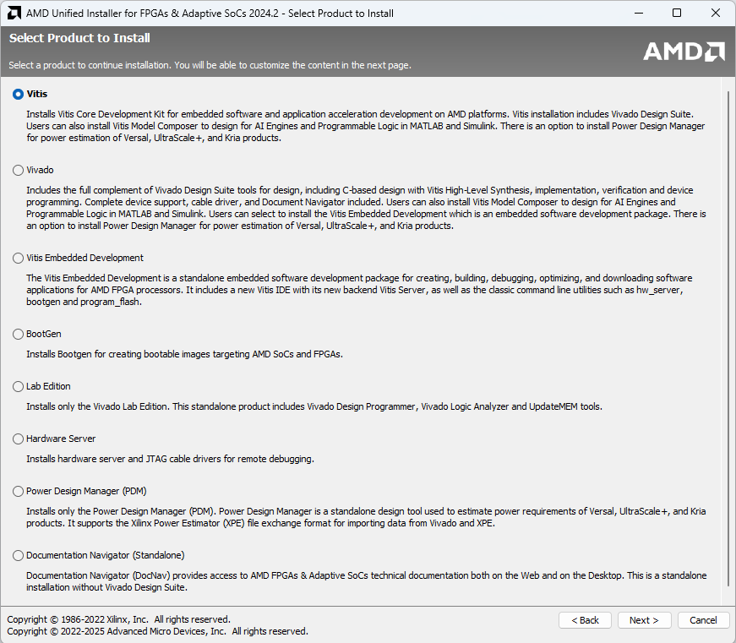

Select only the **Artix-7** devices

Accept the license agreements

Leave the default directory; change to **All Users**

Start the install…. Then go to the gym because this will take an hour.

Once installation is complete you probably need to reboot.

Open Vivado with this icon

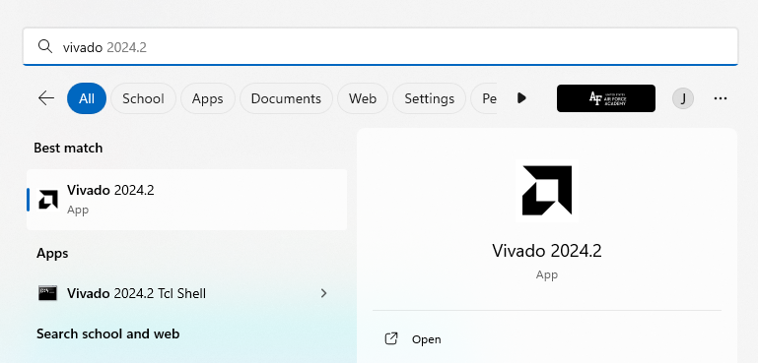

If you see this, congratulations!

